Mirror Image
RULES: Practical Shooting Handbook, Latest Edition COURSE DESIGNER: Jodi Humann
START POSITION: Facing up range with hands on knee caps with toes on either corner of rear fault line. Handgun is loaded and holstered per 8.1.1 and 8.1.2.
STAGE PROCEDURE  Upon start signal engage targets as they become visible. PP1 activates T1 and PP2 activates T9. T1 and T9 need to be activated but are disappearing targets. | SCORING  SCORING: Comstock, 20 rounds, 100 points  TARGETS: 9 Metric, 2 Steel  SCORED HITS: 2 Best per target, steel down = 1A  START-STOP: Audible - Last shot  PENALTIES: Procedural. -10  No-shoot hit. -10  Miss. -10

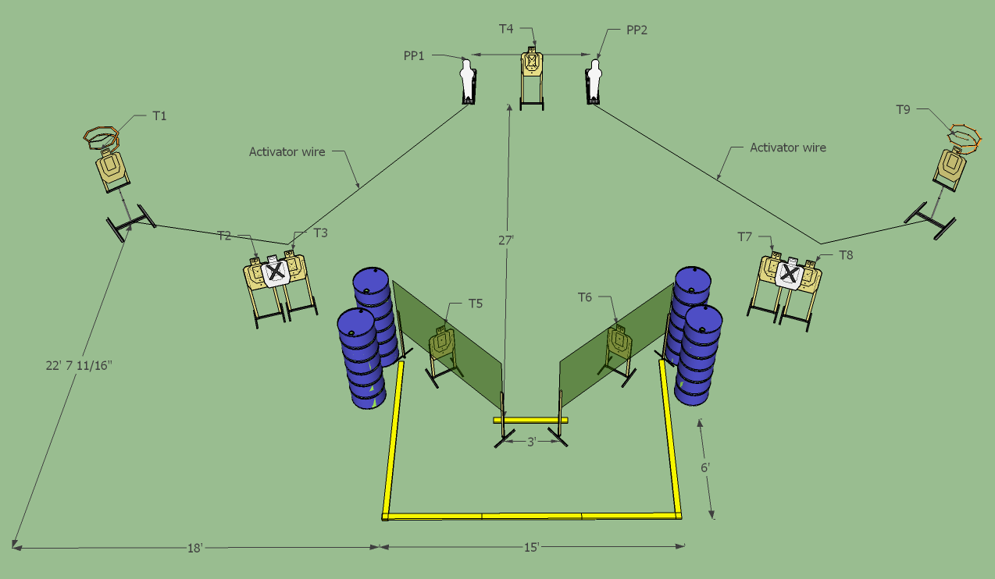

SETUP NOTES: Each side is a mirror image so measurements are also mirrored. T1 and T9 should not be visible from front fault line and watch for shoot throughs from T2 and T8. T5 and T6 are 45 degree angled target stands. |  | RO NOTES: Barrels are soft cover.

